Deployment Guide
- Install Wordpress
- Put product_theme dir to wordpress theme folders
- Activate The theme
- Go to wp admin, select menu Import > Wordpress
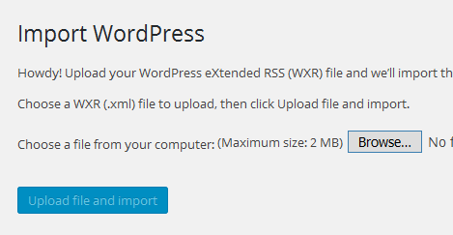
- Import the export.xml provided
- For Create product, create product post type. Fill the title, excerpt, and to add price add custom field "price". And to add thumbnail using featured image of post.
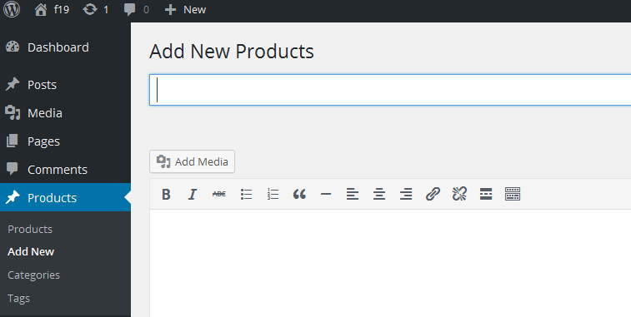

- Import the export.xml provided
- For creating menu top: Goto Appearance > Menus. Create menu with name "top", and add the menus
- For creating menu main: Goto Appearance > Menus. Create menu with name "main", and add the menus

If you have problem, please contact me

